(Approx. 453 words)

Interdrone Conference
Author: George Harding, Treasurer, Tucson Computer Society, AZ
www.aztcs.org
actuary110 (at) yahoo.com

The Interdrone Conference, as you might guess, is about drones: how they are being used in industry, agriculture, first response, fire, police and more.

The Keynote speaker, Dan Ewell, FAA Deputy Administrator, said that there are now 1.4 million registered drones and 50,000 drone pilots that have passed Part 107 (which is required to fly drones other than for recreation).

Interestingly, drone use is now much less personal leisure and more commercial utility. Many of the sessions at this conference were oriented to first responders.

As the conference was occurring, a hurricane was wreaking havoc in North Carolina. Several of the panelists were from North Carolina and were dividing their time between sessions and communicating with the Governor! A few left the conference in order to be on the scene at the coast.

I was surprised by how many fire, police, and rescue organizations had formed their own drone teams, with a well-thought-out training plan and organized practice field exercises.

There were several panels put on by fire first responders, showing how they employ drones to do work that would be too dangerous for firefighters to attempt. One of the newest tools for fire groups is FLIR, an acronym for Forward Looking Infrared Radar. It can be used to identify hot spots that cannot be seen by our eyes.

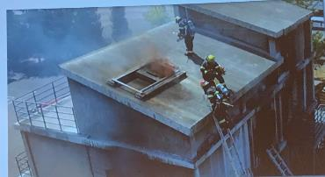

There are filters that can be used by a FLIR device to make the image more understandable: black hot, which makes the warm object black; white-hot, which makes the object white; ironbow, which makes the object golden. Each is useful in certain circumstances.

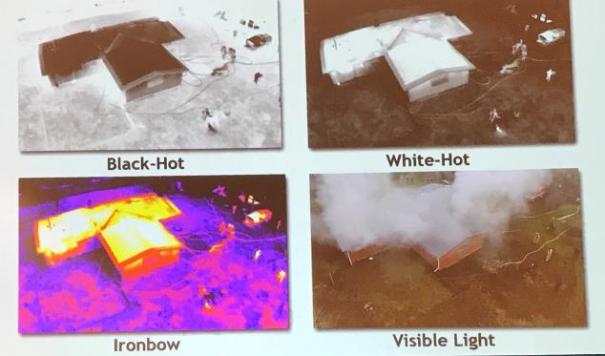

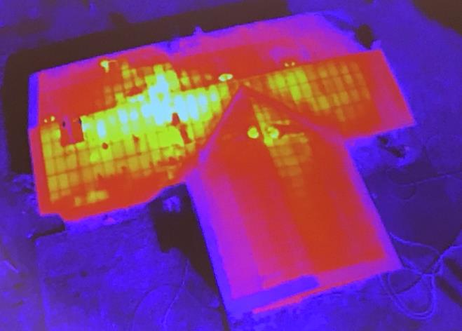

Some other applications of drones for first responders and others are landslide inspection, to see into areas that an inspector may not be able to go; storm damage assessment, to get a broader view of the affected area; crash scene reconstruction; package delivery to isolated persons, especially medicines.

One area of progress in eliminating dangerous situations is drone detection. Airports, especially, need the ability to identify drones that may impact commercial aircraft. There are several systems that can identify a drone, but few that can eliminate the physical threat.

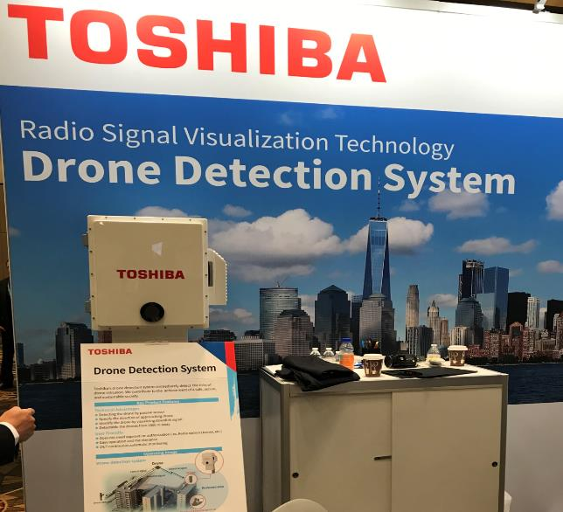

One area that is very important to those who fly drones is insurance liability. I did not see any vendors of insurance coverage at this conference, which is surprising.

The TV and cinema industries continue to use drones to enhance their video coverage at relatively low cost. Drones give the ability to view a scene from a distance, without the use of expensive helicopters.

The drone industry will continue to expand to meet the many uses of these new devices.

Interdrone
www.interdrone.com
Admission: various prices, depending on access

